Week 2 Lab Task
Information Gathering (OSINT)
NIAI NAVTTC — Certified Ethical Hacker (CEH) Course
⚠ Important: All tasks must be performed only in your isolated virtual lab environment. Never test on real networks or systems without explicit written permission.

Task: Investigate a suspicious domain. Analyze domain registration details, check for potential malicious activities, and provide actionable intelligence for an incident response team.
▶ Write Your Intelligence Report
Document the following findings in a structured report:
- Who owns the domain? (WHOIS data)
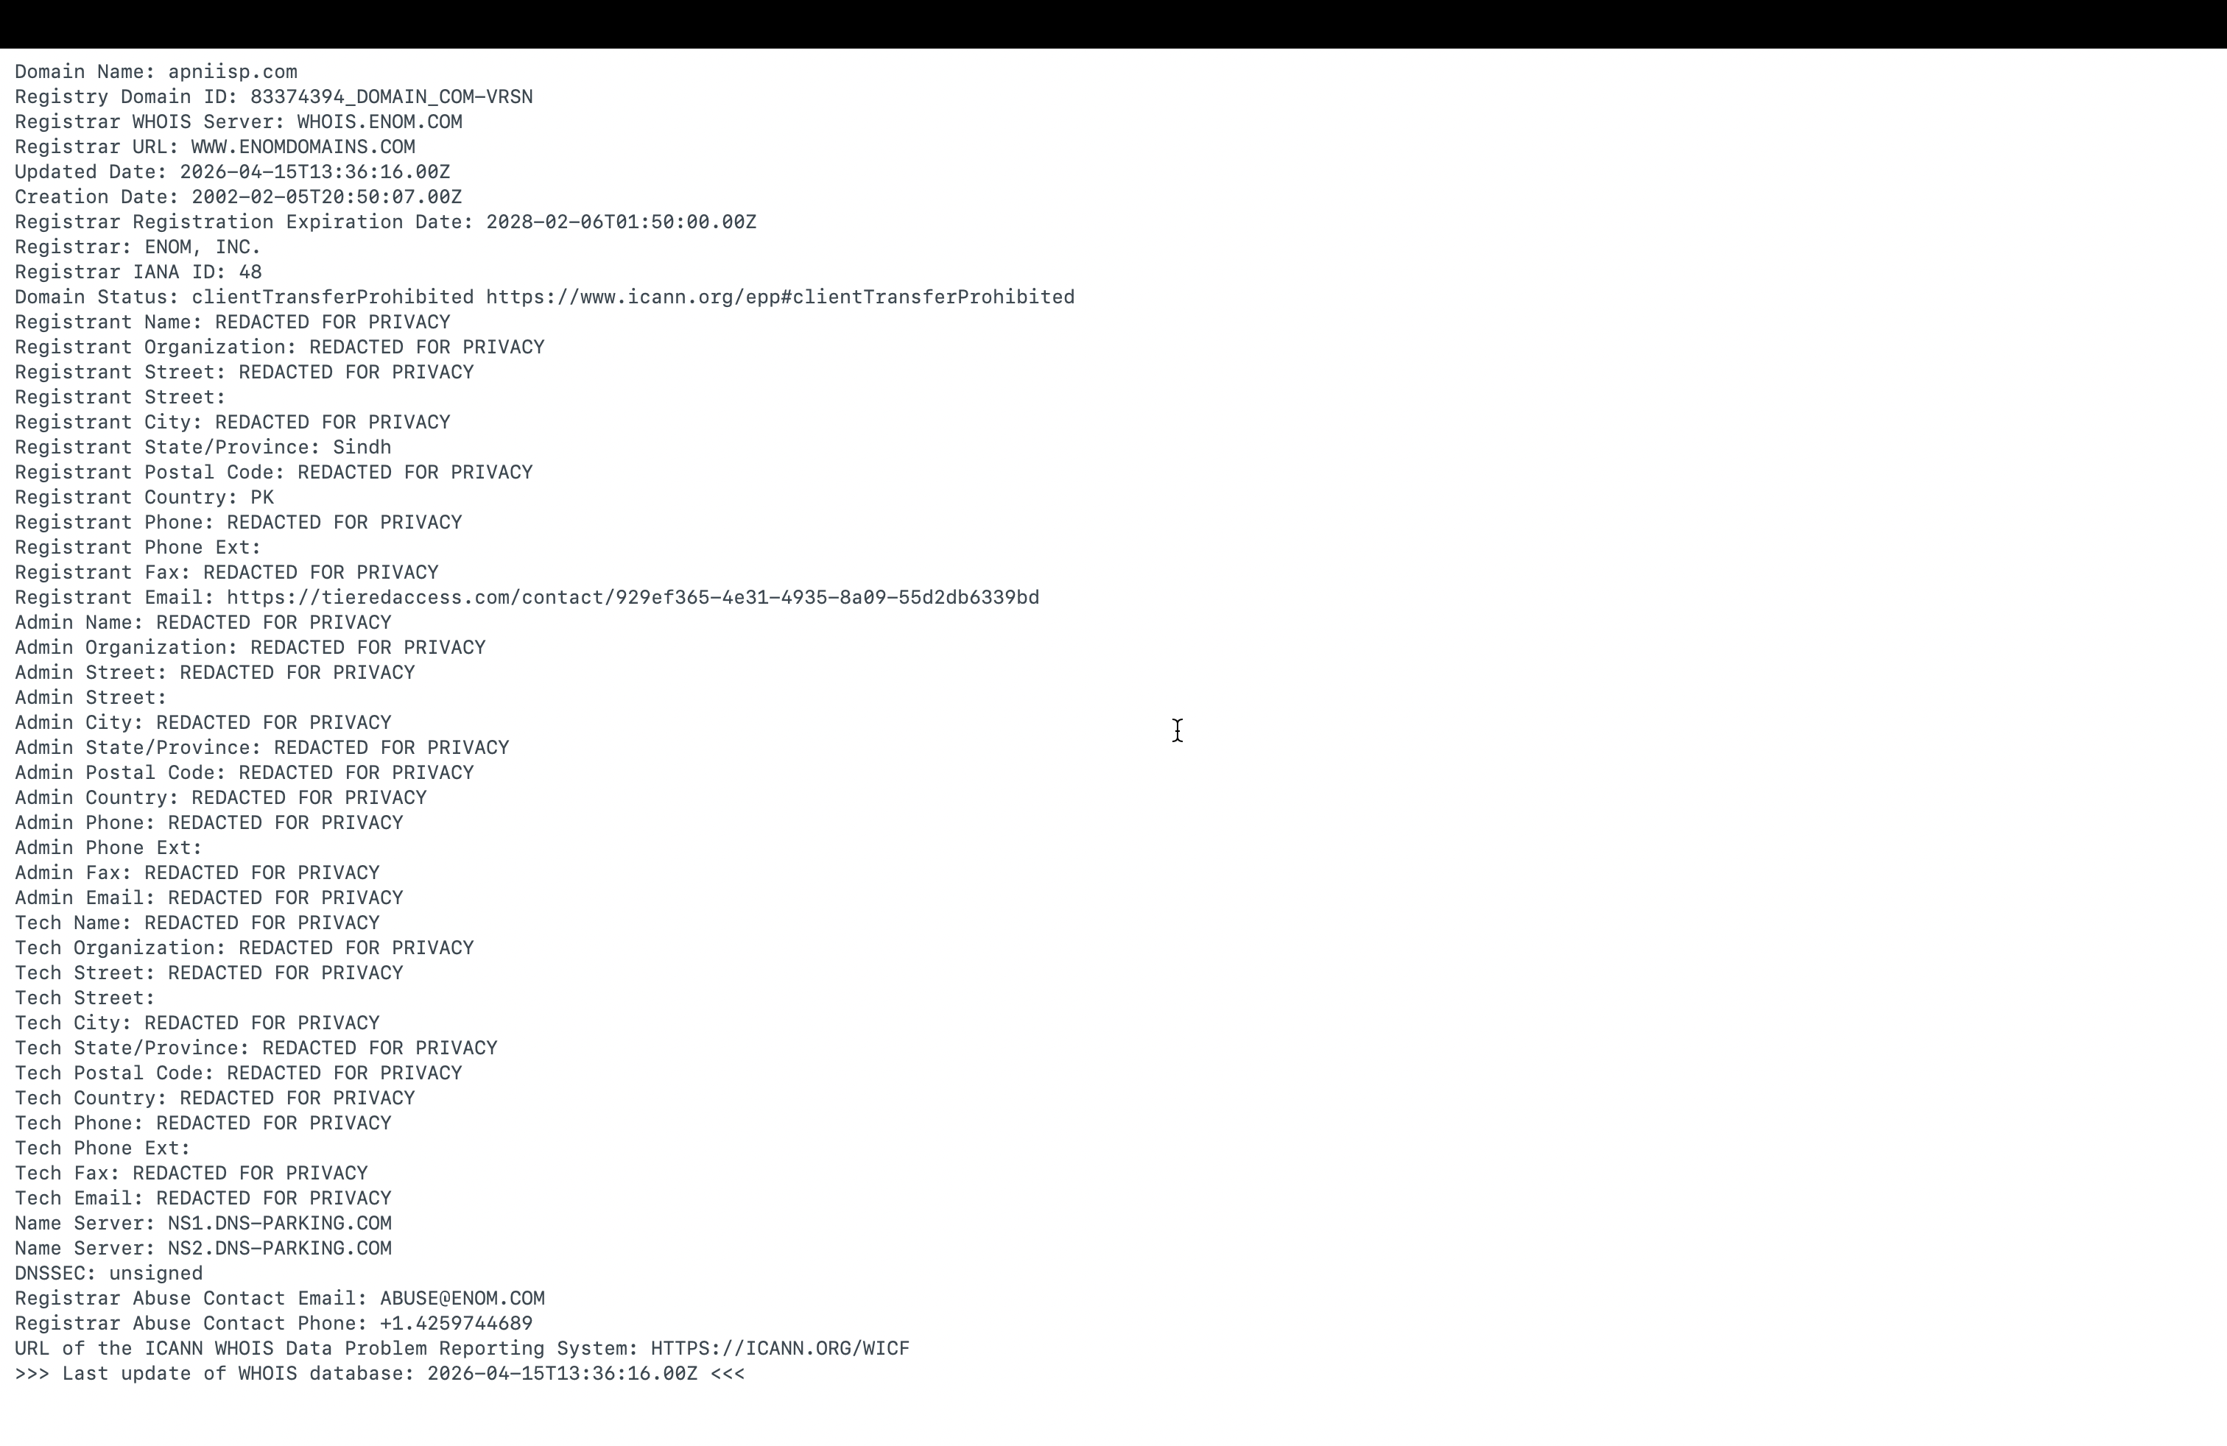

- What IP addresses are associated?
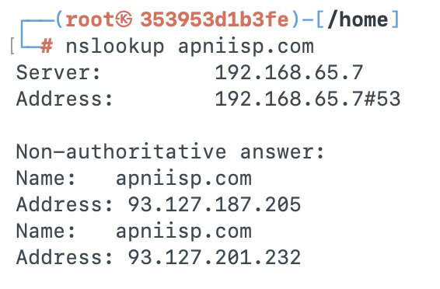
What emails or subdomains were found?
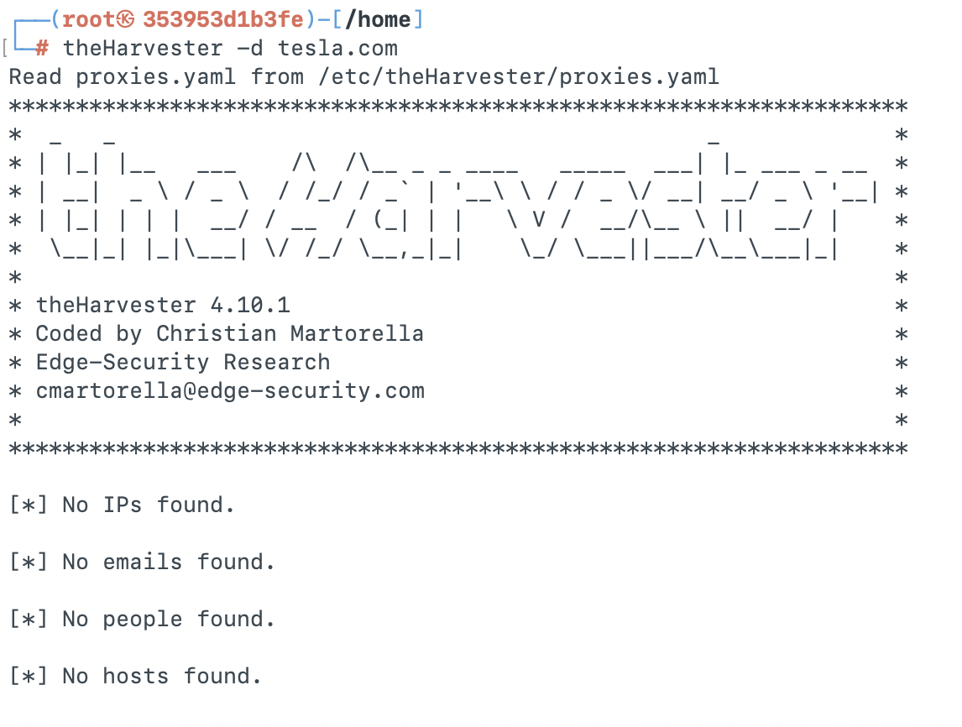

- What ports/services are exposed on Shodan?
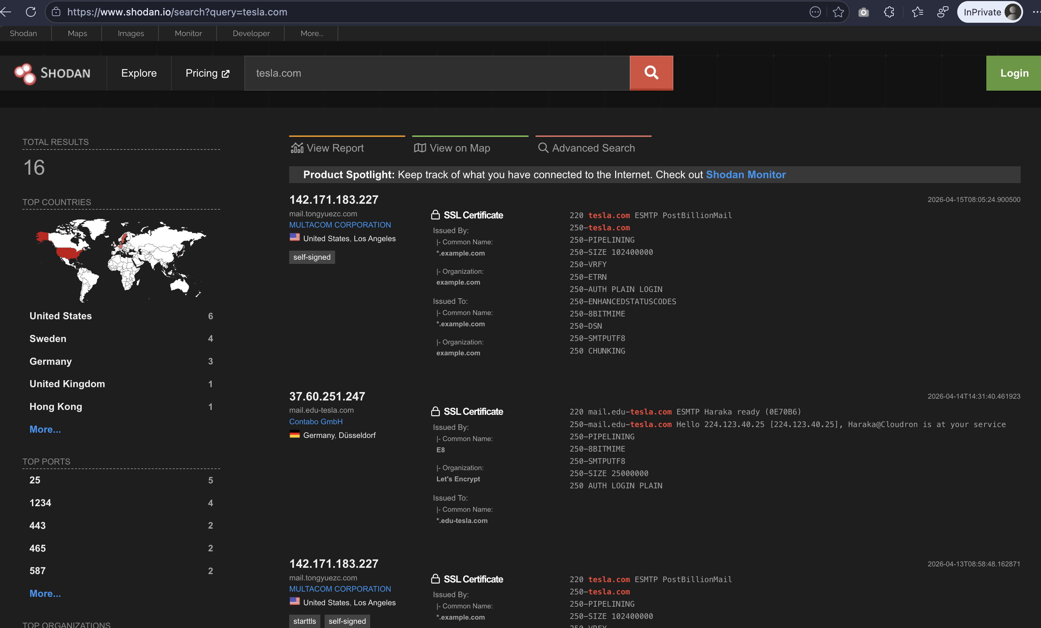

- Any suspicious indicators?
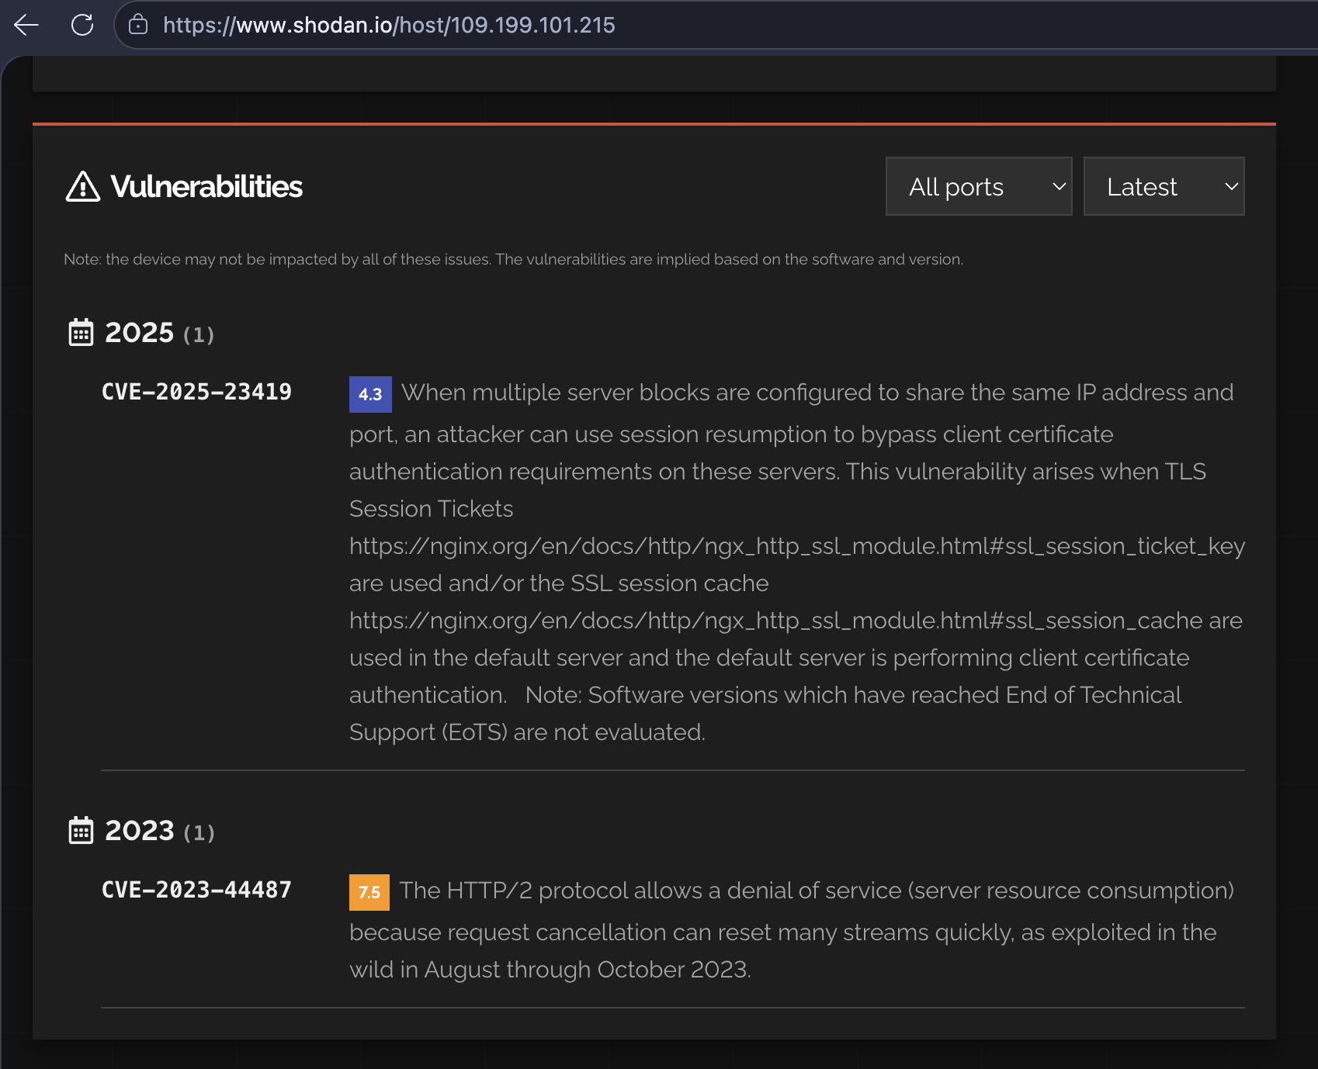

🎯 Goal: Produce a structured intelligence report on a domain including ownership, DNS records, exposed services, and any suspicious indicators of compromise.

